This does not create anything.
It queries AWS for your current identity info, mainly:
- account_id
- arn
- user_id
You use account_id later to make the bucket name unique and to scope the policy to your account’s log path.
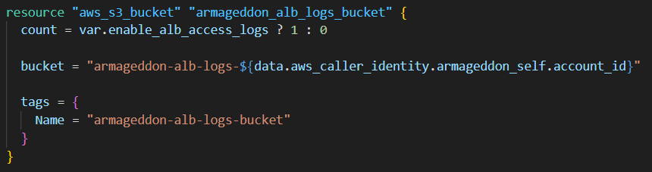
- count = ... ? 1 : 0 means:
  - If var.enable_alb_access_logs = true → create 1 bucket
  - If false → create 0 buckets (resource doesn’t exist)
- The bucket name includes your AWS account ID so it’s globally unique (S3 bucket names are global).
Because count was used, the bucket is referenced as a list later:
- aws_s3_bucket.armageddon_alb_logs_bucket[0] = the one bucket that exists (when enabled)
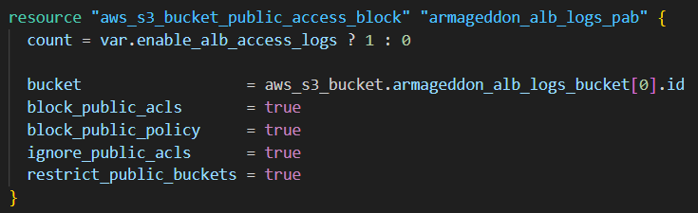
This turns on S3’s “no public access” guardrails:
- block_public_acls: prevents public ACLs from being set
- ignore_public_acls: ignores any public ACLs that might exist
- block_public_policy: prevents bucket policies that would make it public
- restrict_public_buckets: restricts if it somehow becomes public
Net effect: the bucket can’t be public.
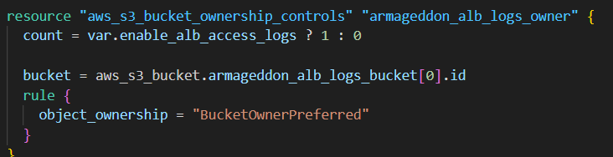
This configures how object ownership is handled when another AWS service writes objects to your bucket.
- BucketOwnerPreferred means:
  - If the uploader sets the right ACL, the bucket owner becomes the object owner.
- This can help avoid “I can’t read my own logs” type problems when services deliver logs.
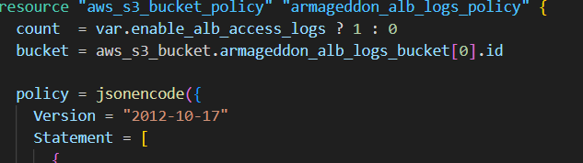
This attaches an IAM-style policy to the bucket.
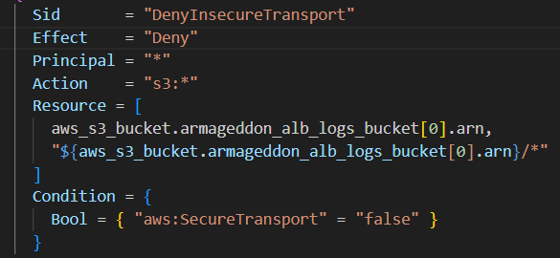
Denies any S3 action if the request is not using TLS/HTTPS.
This is a common security control to prevent accidental plaintext access.

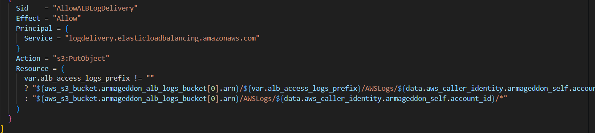 Allows the ALB log delivery service principal to:
- s3:PutObject (write log files)
Only into the expected log folder path.
The Resource uses a conditional:
- If you set alb_access_logs_prefix (like alb-logs) logs go under:
  - s3://bucket/alb-logs/AWSLogs/<account_id>/...
- If prefix is empty, logs go under:
  - s3://bucket/AWSLogs/<account_id>/...

